**Assignment 5**

**Web Design Evaluation**

Rekha Rani

8967222

Web Site Design (2023-2024)

Conestoga College

PROG1836 (100)

Pratish Shelar

February 14, 2024

**TOPIC- WEB DESIGN EVALUATION**

1. **URL of the Website**: <https://alistapart.com/>
2. **Name of the Website**: A List Apart
3. **Target Audience**: A List Apart primarily targets Web designers, Web Developers, and those interested in Web Design and Development, including Professionals and Enthusiasts.
4. **Screenshot of the Home Page**:

Bottom Page

Top Page

1. **Indicate the type(s) of Navigation Evident:**

A List Apart primarily uses top navigation, comprising various categories such as **articles**, **topics**, **events**, **language,** and **write for us.** Additional navigation within the footer or sidebar may exist depending on the page.

1. **Design Principles of Contrast, Repetition, Alignment, and Proximity are applied:**
   * Contrast: A List Apart uses contrast effectively to highlight essential elements. For example, the article titles are typically displayed in larger font sizes and bold to stand out against the rest of the content. There's also a contrast in color between the text and the background, making the content easy to read.
   * Repetition: Throughout the website, there is consistency in design elements such as typography, colors, and the overall layout. This repetition helps create a cohesive and unified experience for the users navigating different pages.
   * Alignment: The content on A List Apart is well-aligned, contributing to a clean and organized layout. Text and images are aligned horizontally and vertically, creating a visually pleasing structure and making it easier for users to scan and read the content.
   * Proximity: Related elements are grouped closely together, enhancing the readability and understanding of the content. For example, navigation items are grouped in the top navigation bar, and related articles are often grouped on the homepage or within article pages.
2. **Recommend one improvement for the Website:**

One potential improvement for A List Apart could be to enhance the visual hierarchy of the homepage by experimenting with different layouts or emphasizing certain sections more prominently. This could help draw users' attention to featured articles or important updates more effectively.

**SITEMAP FOR A LIST APART WEBSITE**

HOME PAGE

TOPICS

WRITE FOR US

EVENTS

LANGUAGE

ARTICLES

English

About

Code

Past Events

Recent Article

Authors

Content

About Our Events

Achieved Article

Masthead

Italian

Design

Topics

Write For Us

Industry and Business

Style Guide

Process

Contact Us

User Experience

Permission and Copyright

Sponsorship

**WIREFRAME OF THIS WEBSITE**





LANGUAGE

WRITE FOR US

ARTICLES

EVENTS

TOPICS

WRITE FOR US



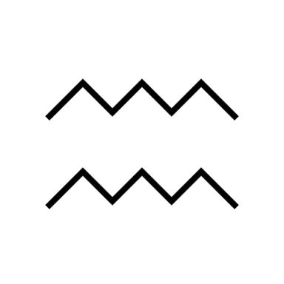

ABOUT



AUTHOR



MASTERHEAD



 WRITE FOR US



WHAT WE ARE LOOKING FOR





STYLE GUIDE



CONTACT US



SPONSERSHIP



ABOUT AUTHORS MASTERHEAD STYLE GUIDE CONTACT SPONSERSHIP FOLLOWUS:EMAIL.FACEBOOK . TWITTER